**Implementation of ALOC Selection Algorithm on Android Mobile Device**

Daria Tolmacheva

Colorado School of Mines, Spring 2014

**I. Introduction**

Most of mobile applications use GPS for tracking user’s location. However, GPS services on mobile devices consume a lot of battery usage. There are several different methods that can track user’s location that are more energy efficient. The use of sensing modalities such as Wi-Fi and Cell tower services are possible options for tracking location with consuming less battery life, however there is a tradeoff between power and accuracy of measuring user’s location. The paper, Energy-Accuracy Trade-off for Continuous Mobile Device Location, presents ALOC algorithm that selects a sensing modality for each time step based on the input of available sensing modalities and the desired accuracy. The algorithm uses four sensing modalities: GPS, Wi-Fi, Cell Tower, and Bluetooth. The paper classifies each sensing modality based on its measuring location accuracy in meters and power usage in units of mJ. The following tables rank the respective modalities according to those classifications.

|  |  |
| --- | --- |
| GPS | 6000mJ |
| Bluetooth | 4000mJ |
| Wi-Fi | 600mJ |
| Cell Tower | 20mJ |

Table1: Energy usage ranked by modality

|  |  |
| --- | --- |
| GPS | 10m |
| Bluetooth | 10m |
| Wi-Fi | 500m |
| Cell Tower | 50000m |

Table2: Accuracy range ranked by modality

Table1 shows that GPS has the most power usage however it has also the highest accuracy range as shown in Table2. On the other hand Cell Tower has the lowest power usage but its accuracy range is along 50000 m of uncertainty.

**II. Implementation of Sensing Modalities**

Each sensor modality was implemented in its own class. The Android provides two different type of location: fine location, which is used by GPS, and coarse location. Obtaining GPS location was done using Android LocationManager.GPS_PROVIDER. The accuracy value for GPS measurements was computed using HDOP value from running Location.getAccuracy() method. The HDOP was described more in the original paper.

The coarse location for Android devices uses Google hidden API to return geolocation coordinates in Latitude and Longitude by using one of the two modalities: Wi-Fi and Cell Tower. This method is abstracted and it is unknown which sensor modality was used to compute the location. The implementation of ALOC requires those two sensor to be separate. To implement Wi-Fi modality, the Android device scans for all visible Wi-Fi access points and obtains the list of the corresponding BSSIDs using the Android BroadcastReceiver. Then the Wi-Fi tracker generates an http request using Android AsyncTask to Mozilla server that provides geolocation in latitude and longitude based on a set of Wi-Fi MAC addresses. The Bluetooth location tracker is implemented in a similar manner to Wi-Fi. Android BluetoothAdapter uses BraodcastReceiver to scan for Bluetooth devices and obtains its MAC address. Using the access points, it then generates and http request.

Getting location with Cell Tower is implemented in similar manner as Wi-Fi. The Android TelephonyManager obtains the list of visible cell ids. The next step can be implemented by obtaining a file with all cell IDs that match to corresponding latitude and longitude. Another approach, that was implemented, is to use the same Mozilla server with constructing http request with the list of Cell Tower IDs. As for the Wi-Fi, the server returns the accuracy in meters for Cell Tower requests.

**III. Implementation of ALOC algorithm**

The implementation of ALOC was done in the MainActivity thread. The algorithm uses probability distributions to measure the error and accuracy in order to select sensor. All distributions were implemented as ten-by-ten matrices that store probability values. Each grid represents one meter. The prior and prediction distribution were initialized to uniform distributions since it at time 0 the user doesn’t know its location yet. All the sensor modalities were calculated using Gaussian formula, as described in the original paper, with sd parameter being set to the accuracy value in meters for each sensing modality.

Whenever a sensing modality is chosen and measures the location, the prior distribution is set to 1 at that location. The predicted location is therefore set based on the displacement in meters from the center of the grid. Once the prior is set to new measurement, the new posterior is calculated using the sensor model for the chosen modality applied to the prior distribution. The new posterior distribution is set to be the new prior for the next modality selection.

The prediction probability is calculated using the last two measurements. At time 0, the maximum distance and maximum angle are chosen to calculate the new location at next time step. At other times, the distance and angle are obtained using the direction and distance traveled in the last time step. The probability distribution is set using Gaussian formula centered at predicted location, on a grid that has center representing the current measured location. The sd parameter for the Gaussian is calculated using the difference in meters between the last prediction and current measurement to represent how close last prediction was.

At each time steps, the sensor is selected using the probability distribution of our predicted measurement using a different sensing modality and also the trace of covariance of the posterior distribution. The error is computed for each sensor and if the error was small enough to match the accuracy input variable then the sensor is added to the possible next sensing modality. After obtaining the list of all modalities that satisfy accuracy requirement, the sensor with the least energy usage is selected based on pre-computed energy models for each sensing modality.

**IV. Observations**

The distribution view was created to track probability distributions for different data. Any distribution can be written in a file and then the distribution view can be opened to graphically represent that data. Below are a few images of the distribution views. The grid sizes can be adjusted for different data sets.

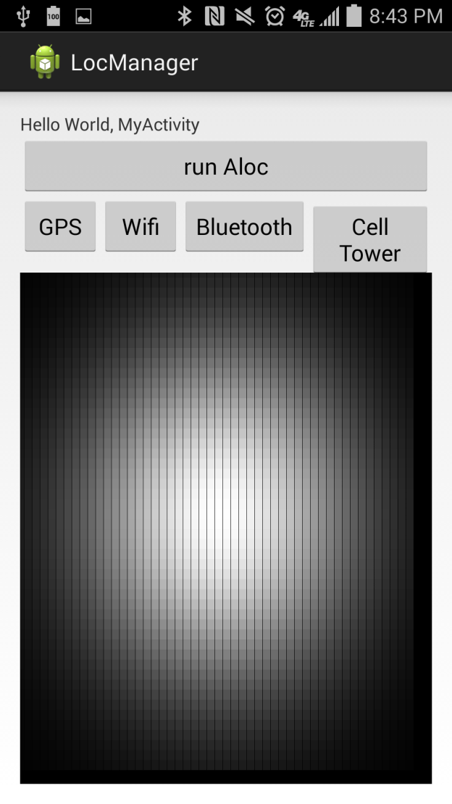Image1: Distribution view for GPS sensor model

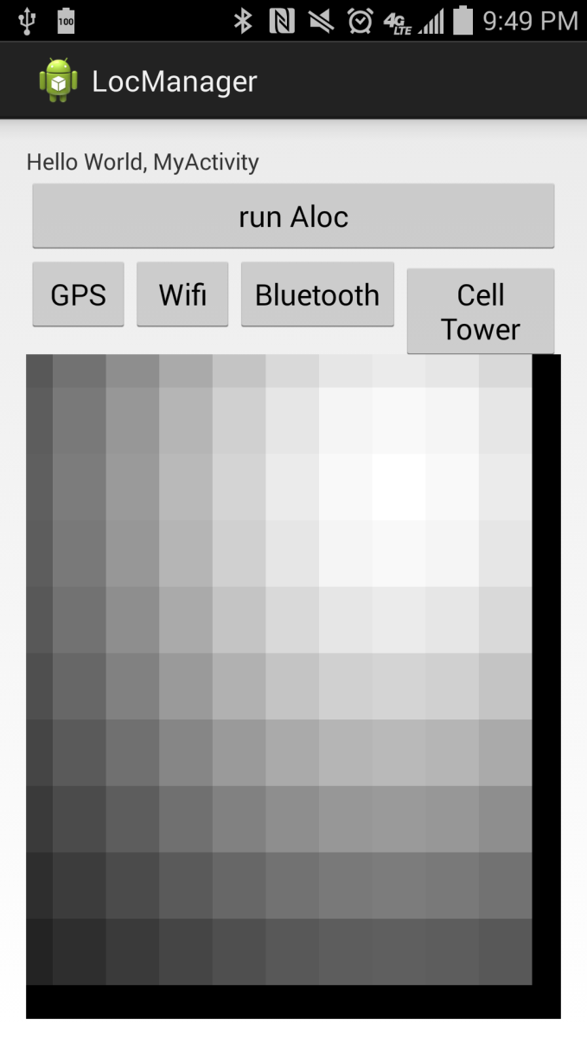

Image2: Distribution view for prediction distribution

**V. Future Work**

The original idea of implementing location tracking sensor modalities and sending http requests does not work with ALOC algorithms. Since both Wi-Fi and Cell Tower trackers require Broadcast Receiver and http request generator, the main thread cannot be suspended to wait for those threads to complete. There needs to be refactoring done to accommodate this problem in Android.

Another improvement that needs to be made is the speed up of calculating the posterior distribution and covariance matrix. The paper suggests that the smaller grid being used to only compute the non-negligible values. This algorithms attempts to shorten the grid by picking low and high indices where the values are negligible, however the computations are still very slow for large grids.

The implementation of ALOC was done using Eclipse and AT&T Samsung Galaxy S4 mobile device and the Android TelephonyManager was not able to find any neighboring cell towers besides the cell tower it is connected to. This problem should be resolved in order to provide better accuracy computation for Cell Tower location.

It is possible to also predict location in 3D space using the altitude parameter. Another sensing modality can be implemented to determine the altitude in order to distinguish location within multilevel buildings.

**V. References**

[1] Energy-Accuracy Trade-off for Continuous Mobile Device Location, LIN Kaisen, KANSAL Aman, LYMBEROUPOULOS Dimitros.